**Outside the Inn**

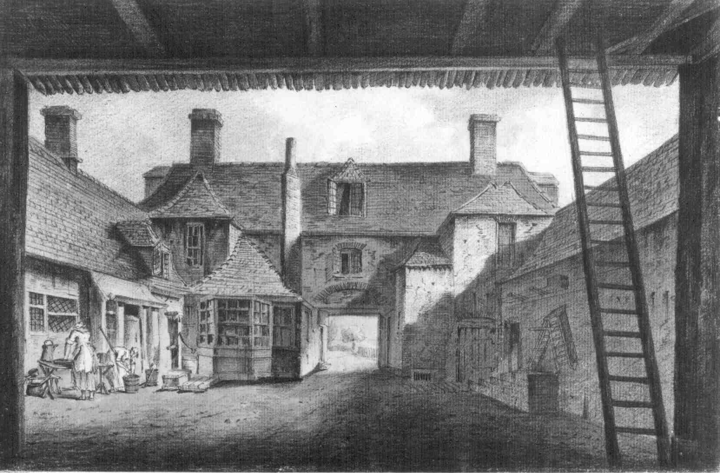

The Inn is a large building which has been made up of lots of smaller separate buildings over time. Some of these would’ve been built in a different time period and therefore will have a different architectural aesthetic. The Inn will also feature various outdoor areas (such as courtyards) which are still considered part of the grounds.

The Inn should have a feeling of being multiple people’s homes, a large multi-bar tavern and also a rural hotel.

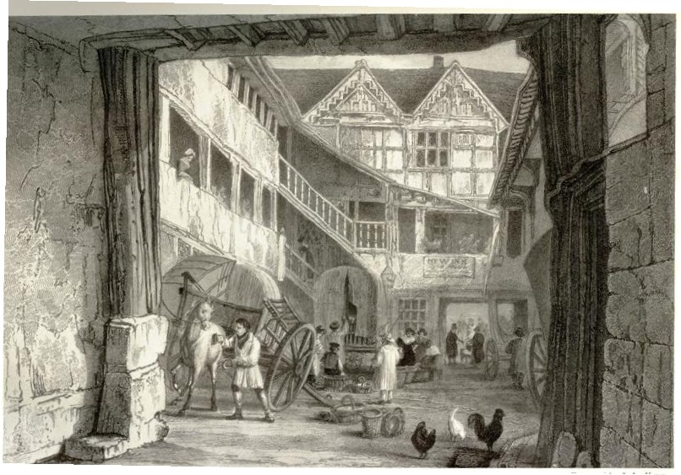

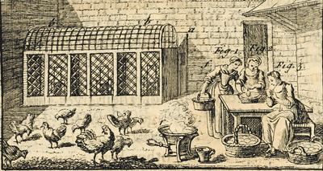The building will have multiple entrances, and accommodate both pedestrians and horses/coaches, so will need a variety of different sized entryways into appropriate courtyards. This reference image shows a coach-sized entrance to what would be a courtyard dropping off area (sort of like a taxi rank).

Some of the outdoor areas will be a lot smaller and more functional in purpose, such as this small worker’s area, used for collecting eggs from the chicken coop. This would be for ease of access to the kitchen and would likely be close by (if not directly outside of) the kitchen room.

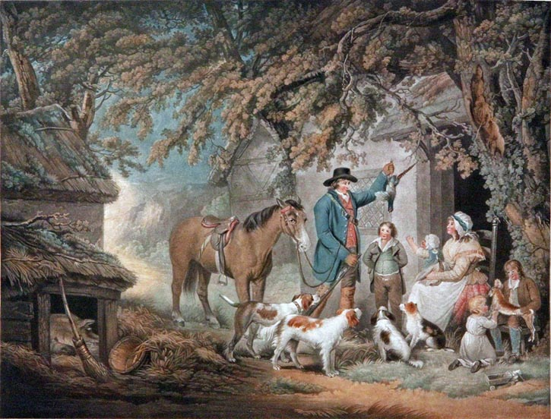Some smaller utility buildings can be found outside of the main Inn location. Some would be tool sheds, others might be outdoor cellars (such as a grain storage or supply closet).

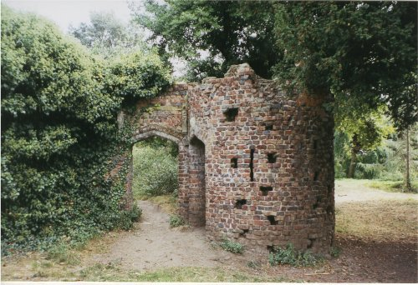

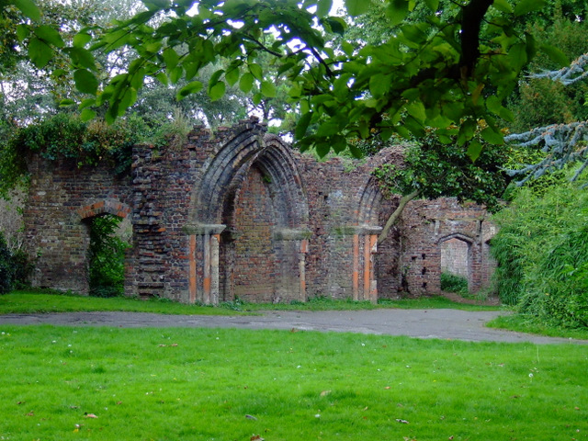The grounds for the building will be surrounded by tall hedges and old medieval ruins from the fort that used to surround the area. Some of the Inn buildings were originally medieval buildings which made up the inner grounds for the fortress. The walls have since fallen into disrepair but still mostly surround the estate. This will serve as a functional barrier to stop the player from leaving the grounds whilst in the exterior areas.

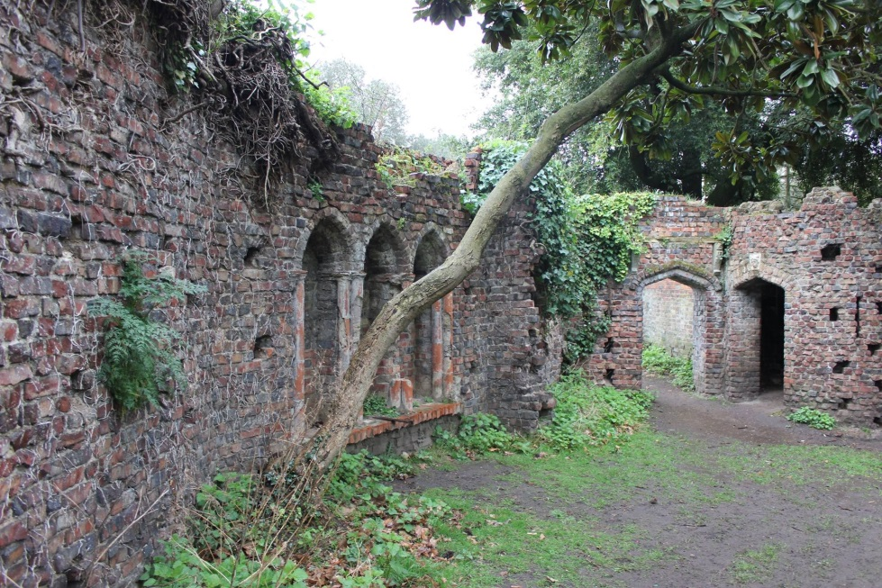The medieval wall should be tall enough to obviously block the player, but not still noticeably ruined (and clearly not as tall as it once was).

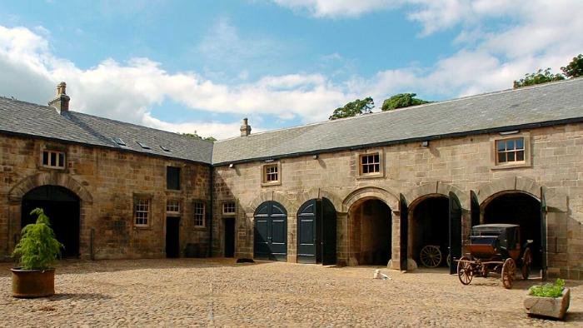

An example of a coach-stable courtyard. This type of area would be present in the more upper-class parts of the Inn (and the most recent, so 18th century style as pictured).

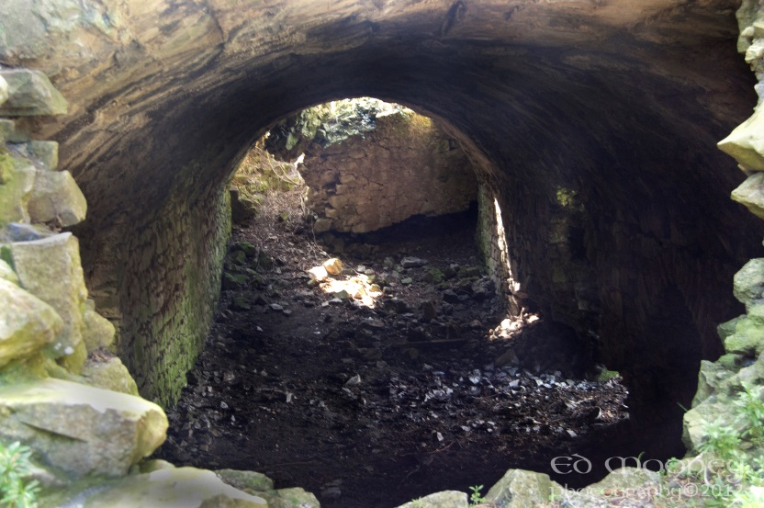Here is an example of how one of the exterior areas could be used to access the interior. A ruined medieval section gives way to a tunnel. Further down the tunnel would be a door which leads to a store room or wine cellar for the main building.